St. Lucie River railroad bridge would serve as virtual natural gas pipeline
In a March 3, 2016, letter to Florida East Coast Railway, Karl Alexy of the Federal Railroad Administration said Liquefied Natural Gas offers a new opportunity for railroads, presents a new challenge for safety regulators, and transporting large quantities in a single train presents unique safety risks. He also noted that LNG freight would eventually share the routes with high-performance passenger trains, traveling at speeds up to 110 mph. Top speed for LNG is 40 mph through densely populated communities.
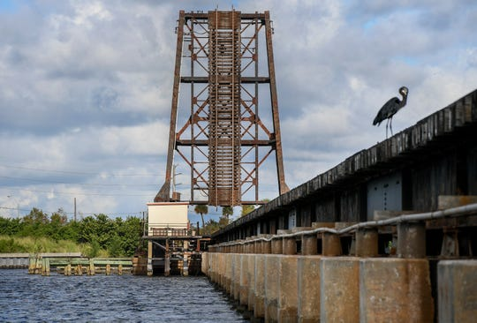
The Florida East Coast railroad bridge is seen spanning the St. Lucie River, parallel to the Roosevelt Bridge, on Wednesday, Oct 30, 2019, in Stuart. Virgin Trains USA has announced their intentions to replace the aging bridge, a single track span, with a double-track span costing around $100 million and taking around two years to build. (Photo: ERIC HASERT/TCPALM)

New Fortress Energy’s Miami affiliate, American LNG Marketing, is authorized by the Department of Energy to export LNG from the Ports of Miami, Everglades, Palm Beach, Jacksonville and Canaveral. American began exporting LNG in 2016.
On March 13, 2017, the FRA authorized Florida East Coast Railway to haul 10,000-gallon ISO containers of LNG produced at the Miami plant to ports of Miami and Everglades. Energy Transport Solutions, also a subsidiary of NFE, is now seeking authorization to transport LNG in 30,000-gallon rail tank cars.
The Floridian Natural Gas Storage LNG facility, proposed for Indiantown, plans an addition for loading rail cars. Floridian will export LNG from ports of Miami, Palm Beach, Jacksonville, Tampa, Everglades, Canaveral and Manatee (from Department of Energy Docket No. 15-38-LNG).
Unlike LPG (liquified petroleum gas), a breach in an LNG container cannot be capped, and exposure to thermal radiation (heat) from an LNG pool fire or flash fire could result in fatalities, serious injuries and property damage. Transporting LNG by rail over deteriorating infrastructure, including bridges, such as the St. Lucie River railroad bridge, increases the risk.
Rail tank cars will form a virtual rolling natural gas pipeline on wheels, but taxpayer monies and costly rail infrastructure improvements will be required before any gas starts flowing. - Cecile Scofield, Palm City

